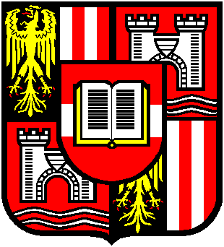 | Johannes Kepler Universität Linz  Institut für Kulturwirtschaft  und Kulturberufsforschung  Vorstand: A.Univ.-Prof. Dr. Ingo Mörth

Project exposé

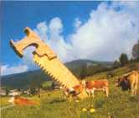
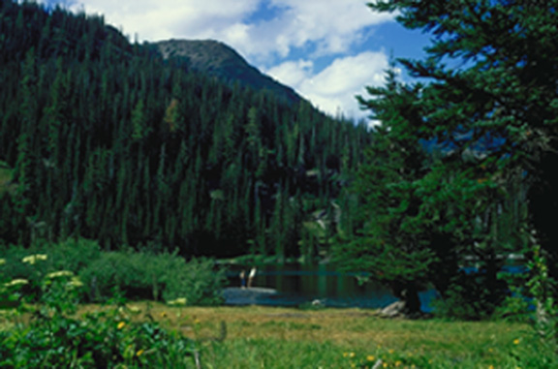

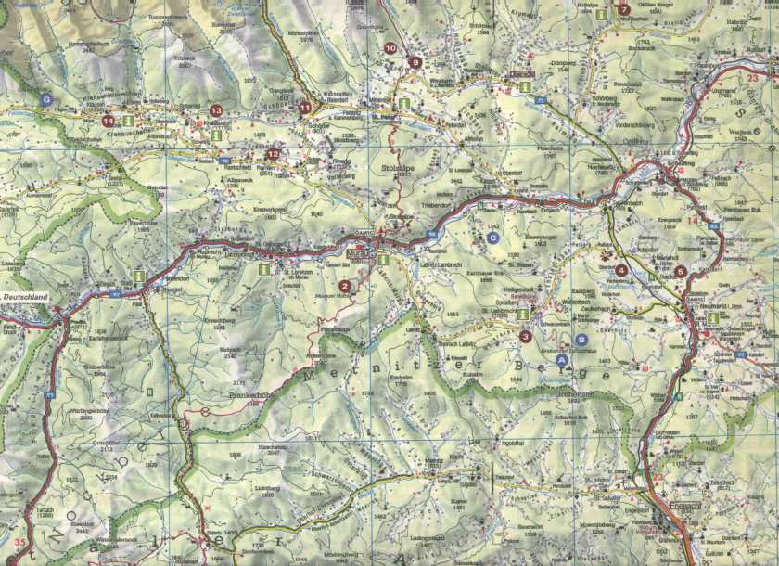

Sustainable regional development
by coping with conflicts of land utilisation
in a typical Alpine landscape

Towards the elaboration of a model
of socially, culturally and environmentally compatible
regional development by the example of the woodland scenery
of the district Murau / northern Styria

April 2000

A-4040 Linz, Freistädterstraße 313/2
Tel. 0732/ 2468-361, 7151DW (Sekretariat); Fax 7151, 243DW;
eMail: kuwi@jk.uni-linz.ac.at

Contents
1 Subject and aim of the study 4
1.1 The concept of sustainable regional development 4
1.1.1 Plurality of dimensions 4
1.1.2 Sustainability 4
1.1.3 The primacy of regional development potentials 5
1.1.4 Endogenous Development 5
1.2 General formulation of the problem: chances of sustainable regional development by coping with conflicts of land utilisation 6
1.2.1 A conflict-theoretical approach: dependence of the perception of landscape on utilisation needs and interests 6
1.2.2 Social compatibility by mediation of utilisation conflicts 6
1.2.3 The importance of environmental compatibility in the process of regional development 7
1.2.4 Cultural compatibility as framework 8

2 The case study: sustainable landscape utilisation and
regional development in the district of Murau as a model 9
2.1 The particular situation in the district of Murau as a selection basis 9
2.1.1 Murau as “Holzlandschaft” („woodland“) 9
2.1.2 Potentials of regional development 9
2.1.3 First steps towards the balancing different interests and needs:
the “Holzwelt” Association 10
2.2 Development and test of a model of socially compatible coping with utilisation conflicts in the region 10
2.2.1 Phase 1: Stock-taking of the landscape images and utilisation needs of the interest-groups 10
2.2.2 Phase 2: Development of a comprehensive model of social compatible coping with utilisation-conflicts 11
2.2.3 Phase 3: Test and evaluation of the elaborated model in view of its social, environmental an cultural compatibility 12
2.3 Generalisation of the instruments of
sustainable regional development 12
3 Research methodology 13
3.1 Methods of stock-taking of landscape-images and
utilisation needs of the interest-groups 13
3.2 Methods of developing a comprehensive model of
socially compatible coping with conflicts of utilisation 14
3.2.1 Analysis of other endogenous sustainable development projects 14
3.2.2 Assessment of the previous steps of regional development
in the district of Murau 14
3.2.3 Monitoring the development of an instrument for balancing
the utilisation needs of different groups 14
3.3 Methods of testing and evaluating the conceptualised model
with regard to social, environmental and cultural compatibility 14
3.3.1 Analysis of the decision-making process 14
3.3.2 Analysis of the conceptualised and implemented development strategy 14

4 Timetable and costs 15
4.1 Timetable 15
4.2 Costs 15
4.2.1 Phase 1 15
4.2.2 Phase 2 15
4.2.3 Phase 3 16
4.2.4 Total Costs 16

5 Literature 17

Subject and aim of the study

The concept of sustainable regional development

Plurality of dimensions
Regional development shall be understood as the “totality of measures to develop a region socio-economically and infrastructurally onto a higher level” (Fischer 1974: 64). This indicates that the one-sided emphasis of some authors (e.g. Hahne 1985, Priewasser/Malinsky 1986, Scharff 1993, Thoss 1983) on economic aims will not be followed, but a broader concept of regional development will be taken as base. This wide-ranging concept of regional development goes beyond a one-sided economic view by including social, cultural and ecological aspects. The crucial point is the improvement of the living conditions of people in defined areas. (cp. Zechner 1998, Sauerborn 1996).
An orientation on the quality of life of the residents draws the attention on the recreational value, the educational value and other aspects of the cultural, social and natural environment. The inclusion of social, cultural and ecological conditions and requirements seems to be indispensable from this point of view. Regional development is therefore conceptualised as a complex of the fields
- social development
- landscape development
- economic development
- cultural development.

Sustainability
This model of sustainable regional development makes a simultaneous consideration of cultural, social, economic and ecological aspects and their interactions possible. It is based on the growing criticism of an one-sided orientation on economic growth (cp. Sauerborn 1996). This critical perspective sees the unrestricted absorption of existing natural, but also social and cultural resources seen as a risk for the next generations. Excessive tourism for example can lead to changes in the social and cultural structure of a destination. (cp. Mörth et al. 1997a) The unlimited exploitation of a forest area will finally lead to the loss of the existing forest stands and all connected ecological and touristic benefits.
Sustainability means in contrast to this the reasonable and cautious use of existing resources. The aim is a form of utilisation, that “satisfies the needs of the present generation without lowering the chances for development of future generations.” (Zechner 1998: 19). Social, cultural, ecological and economic resources should be used in a way, that they are preserved for following generations. The preservation of the existing social (social compatibility), cultural (cultural compatibility) and ecological (environmental compatibility) structures will be an important framework of measures for regional development.

The primacy of regional development potentials
Regional development should be based on regional available resources. This point of view is orientated on the concept of regional development potentials (e.g. Hahne 1985, Scharff 1993, Thoss 1978). This model assumes that any region has not used or not fully used means of production which could be used respectively utilised in an appropriate manner (Scharff 1993: 109). On the basis of existing social, ecological, cultural and economic resources the total development and for that the quality of life of the inhabitants shall be influenced positively.
The regional potentials not only mark the starting point of development. They also filter the possible ways of development and mark the final point. They canalise the development options of a region both in view of the results, that can be achieved, and with regard to the practicable social, cultural, economic and ecological activities in a region.

Endogenous Development
The view of sustainable development of the regional potentials leads to a demand for a reasonable use of the resources of a defined area. The quantitative stock of resources as well as their specific quality shall be preserved on a long-term basis. The preservation of the existing structures of a region can be ensured by a endogenous development-strategy (e.g. Böhm 1996, Hahne 1985, Zechner 1998). Endogenous development indicates “bottom-up” development, which starts from within the concerned social system itself. The hope for a better consideration of the needs and demands of the existing structures is linked to the active participation of the affected population in the region’s development. Control from outside the region is confronted with sovereignty of planning and decision by the inhabitants of the concerned region. Information to the persons concerned can be given from outside, but the processing of these information for a specific development-strategy takes place within the group of inhabitants.

General formulation of the problem: chances of sustainable regional
development by coping with conflicts of land utilisation

A conflict-theoretical approach: dependence of the perception of landscape
on utilisation needs and interests
Landscape with its different options for use and development is object of human processes of perception and expectations. The subjective representation of landscape con not be divided from such socio-cultural notions, which are not genuine elements of a landscape itself. Ipsen (1997) emphasises in his “Theorie der Raumbilder” (theory of spatial images) the cultural and social sources of the human notions of landscape. The meanings inherent to the perception of landscape are not homogenous, but vary with the claims to, needs for and demands on present and expected utilisations of the perceiving persons. The utilisation-needs reflect a facet of the interests of individuals and can be seen as products of their social positions. This approximation to the conflict-potential of multifunctionally perceived natural landscapes is based on a general sociological conflict theory (e.g. Dahrendorf 1996, Krysmanski 1971). This sociological approach brings the dependence of claims and values on social positions to the centre of considerations.
Different social groups differ in their concepts of landscape. Their perception can only be understood adequately if their social position and the corresponding role is taken into consideration. Besides the local residence population, e.g. farmers, tourists, hunters and other holders of specific rights for utilisation, representatives of the local industry, tourism organisations and environmentalists have claims to the landscape. Depending on such different roles and different forms of land-use can be striven for.

Social compatibility by mediation of utilisation conflicts
The divergent interests and expectations are on the one hand starting point of utilisation conflicts, but on the other hand mark the framework of a social compatible development of region and landscape.
If social compatibility is understood as an active process, in which needs of the local groups must be negotiated fairly, models for managing utilisation conflicts and concepts for sustainable regional development fit together perfectly. The treatment of the existing conflict-potential by activating the affected groups for the jointly development of a model of forming and utilisation of natural areas seems to be indicated.
Landscape development at first has to be seen in connection with economic development. The forming and dedication of the regional natural areas has an effect on the region’s economic potential of development. The other way round, the needs of the regional economy are an important determinant of the forming and utilisation of landscape.
A stock-taking of existing utilisation conflicts by analysing the landscape-related expectations and interests of different groups leads to the development and application of a model of negotiation, wherein different groups are represented with equal rights.
Premise of such an instrument, which focuses social compatibility, is the integration of all groups with claims to landscape by simultaneously balancing the existing potentials of influence. The integration of local decision-makers at a political and administrative level shall additionally promote acceptance of the model of solution.
With regard to conflict management it is advisable to use an approach orientated at the concept of mediation. (cp. Böhm 1996). “Mediation is to call a (..) neutral and not involved third party in a conflict, which supports the conflicting parties in their attempts for negotiation and settlement, but have no own (...) power of decision.” (Breidenbach 1995: 4). Aim of such a process is the development of a solution, in which all the involved parties are represented. In such a solution obtained by agreement and accepted by all the involved parties, the preservation of existing social and ecological structures could be realised in the best way. In this way a broad-scale mediation on an organisational level can be the basis of sustainable landscape- and regional development.
Mediation contrasts with other models of conflict settlement by the reserved role of the mediator. The mediator does not formulate suggestions for solutions and has no own power of decision. He limits his role to the direction of the negotiation process and the possible bringing in of necessary information. (Galuske 1999) This aspect of passiveness founds the suitability of the process of mediation for endogenous development processes, because all mediated decisions bear the internal authority of the directly involved parties.

The importance of environmental compatibility in the process
of regional development
Sustainability always includes aspects of environmental compatibility. Models of sustainable regional development must by definition take into consideration the ecological needs of natural areas and therefore the ecological consequences of all different existing and planned forms of land utilisation.
Therefore it is necessary to enrich the negotiation process of utilisation conflicts with the ecological implications of the considered forms of land-use. This enrichment must take place with the scope of the integration of all groups having demands to the regional landscape.
From the synthesis of the needs of interest groups having equal rights but different objectives (e.g. environmentalists vs. wood growing farmers and the wood processing industry) a model of land utilisation should result that is compatible to the postulate of ecological sustainability, too. In brief: the model of social compatible regional development should – by incorporating people which make cological interests their own - automatically generate solutions which meet the requirements of environmental compatibility.

Cultural compatibility as framework
With the Council of Europe culture can be understood as the totality of symbols, of knowledge, values and norms of a society or a group of people, which allows the individuals, "to cope with themselves and the society, including its social and cultural heritage and natural environment", in order to change the social and natural conditions if necessary.
This conception of culture stresses the importance of the socio-cultural identity of the persons involved in the process of regional development (cp. Mörth et al. 1995). The grown regional culture and its potentials for change are both important basis and regulating framework of the endogenous development processes.
Present and future conceptions of landscape and notions of utilisation must always be tested for their consequences regarding regional cultural identity in the process of jointly negotiating the aims and steps of regional development. Cultural compatibility of the regional development therefore contains the aim, that the region stays a "home" (“heimat” in a non-emotional sense) for all concerned persons and groups.

The case study: sustainable landscape utilisation
and regional development in the district of Murau as a model

The particular situation in the district of Murau as a selection basis

Murau as “Holzlandschaft” („woodland“)
The district Murau in the north of Styria is a rural area dominated by large forest stands, a true “Waldheimat” (woodland home). More than 50 % of the district’s area are covered with wood. One fifth of the working population within the district are working in agriculture or forestry. (Esterl 1998)
Wood traditionally plays an important role for the regional self-image. This can be seen e.g. in the foundation of the “Wood museum St. Ruprecht” in 1988 and in the title (“Holzzeit” = “Time of wood”) of the provincial exhibition ("Landesausstellung") 1995, which was held at various locations in the district. Land utilisation and landscape development are deeply connected to wood as a centre for identity and local resources, and consequently to the existence and preservation of the local forest stands.
Even in tourist marketing the region is commercialised as woodland scenery and “Holzwelt”. The foundation of a organisational platform for the groups using the regional forest stands (the “Verein Holzwelt” = “Woodworld Association”) indicates that the process of regional consciousness-shaping around the potentials of forests and wood has just taken place.

Potentials of regional development
Sauerborn (1996:24f.) mentions five starting points for regional development:
- Potentials of basic materials: natural raw materials, fossil resources etc.;
- specific regional know-how, techniques, traditions;
- problem consciousness for the region’s development;
- time horizons that make it possible to combine short-, medium- and long-term measures;
- possibilities of a useful domestic priority in regional economic activities.
The region of Murau can link at least to the first four aspects. Basis of a sustainable regional development in the district of Murau are the large forest stands (potential of basic materials), the historic grown regional identity as “Holzlandschaft” (know-how, techniques, traditions), the request for development, that manifests in the foundation of a platform (problem consciousness), and the readiness for long-term measurements (time horizon). The possibility of an appropriate domestic orientation must be queried first but has to be clarified by research.

First steps towards the balancing different interests and needs: the “Holzwelt”
The traditionally great importance of wood and by that the significance of the shaping and utilisation of the regional wood landscape have lead to the foundation of the association “Holzwelt”. This association is a top-level organisation of groups related to wood – forestry, tourism, wood-processing industry, but also small initiatives in the fields of education, art and exhibition. Basic aims are the coordination of all wood-related activities in the region, the connection of all involved groups and the development of the regional potentials. By that the first steps to institutionalised coping with utilisation conflicts are already done.
As a result of the introduction of a process of negotiation of divergent interests, the region of Murau is well-suited for the development of a model of the sustainable coping with utilisation conflicts.
Important indications for the conception of a model of sustainable regional development can be gained from the scientific assessment of the processes so far and the systematic monitoring of the further development.

Development and test of a model of socially compatible
coping with utilisation conflicts in the region

Phase 1: Stock-taking of the landscape images and utilisation needs
of the interest-groups
The woodland scenery of Murau is a point of intersection of different interests and demands - of farmers, environmentalists, hunters, members of the wood-processing industry, local inhabitants, tourists and representatives of the tourism economy. Some latent and open conflict areas are:
- The request for a touristic development of the landscape is in opposition to the wish for renunciating interventions in the natural environment, a wish generated by considerations of hunting-game and environmental protection. The conflict potential of the ski-area “Kreischberg” should be mentioned as an example in this respect.
- By the wood-processing industry, mono-cultures are favoured for reasons of specialisation and rationalisation, whereas from an ecological – and recreational - perspective a mixed forest must be preferred.
- The claims of the locally resident population unfold in a field of employment possibilities, recreational value and aesthetic experiences. But the demands of the different involved groups are not homogenous. E.g. numerous farmers also offer beds four tourists. By doing so they experience strain between agricultural imperatives and touristical considerations.
From the viewpoint of sustainable regional development, these different needs must be harmonised. Starting with a detailed stock-taking of the particular images of landscape in context with the linked interests and expectations, prevailing conflict potentials shall be revealed and a model of fair negotiation shall be developed.
A first focal point of the study therefore is in the systematic investigation about and analysis of the perceptions of landscape and land utilisation needs. The images of landscape and the demands of the different interest-groups are seen as the basis of their favoured development options.

Phase 2: Development of a comprehensive model of
social compatible coping with utilisation conflicts
A socially compatible coping with the revealed conflicts of utilisation shall take place by means of a negotiation instrument, in which the different social units are represented with equal rights.
By using and referring to the existing network of the “Holzwelt” structured communication processes between all groups having demands to the regional woodland scenery shall be started. The extension of the existing platform with groups not yet represented seems useful (e.g. environmentalists, representatives of local inhabitants with recreational demands etc.).
Conception and implementation of such a broad platform will happen “bottom-up”, by a wide-scale integration of the region’s inhabitants. The researcher in this phase appears as a “consultant”: His role is limited to the support of the endogenous development processes with regard to information and motivation. Decision- authority is definitely not aspired.
Object of the research in this phase is the systematic documentation and scientific monitoring of the social and political process developing such a model on the basis of the assessment of the previous development steps.

Phase 3: Test and evaluation of the elaborated model in view of its
social, environmental an cultural compatibility
In a further step the divergent positions shall be balanced within the framework of the established platform. The researcher shall act as a mediator: He guides the formal procedure of decision-making and ensures the observation of basic communication rules without determination of the aims and contents of the negotiation process.
The expectation for a solution according to the postulate of sustainability is connected to a fair negotiation in a communicative situation without the chance of domination for certain participants. A resulting development concept thus shall ensure the conservation of existing social, cultural and ecological structures.
From a scientific point of view in this phase two aspects come to the fore: first the course of the negotiation process and second the quality of the obtained solution model.
The specific result of the negotiations can only be understood against the background of the process that has lead to it. The jointly elaborated model of land utilisation and regional development shall be analysed if it fits the criteria of sustainability. It will be measured against the preservation of the region’s social, cultural, economic and ecological resources.

Generalisation of the instruments of sustainable regional development
Highest priority of the research project is the development of a general model of balancing the divergent demands on and needs for land utilisation in a region, that can be the basis of a sustainable development strategy.
The applicability of this solution concept, developed from a Murau as a case-study, shall not be restricted to this particular region. General knowledge shall be deducted from the actual working on concrete utilisation conflicts in a specific region.
Negotiation instruments shall be developed and tested which can be transferred to numerous regions. For that, the phase of evaluation of the particular instruments developed within the region must be long enough in order to observe the economical, social, cultural and ecological consequences

Research methodology
The width and differentiation of the questions require the resort to different methodologies and the utilisation of different research methods.
In the phase of beginning (stock-taking of landscape images and utilisation needs) a conception of science orientated on critical rationalism (Prim/Tilmann 1989) can be followed in the sense of an empirical stock-taking from a distance.
Later on (development and test of a coping-model), aspects of action research are introduced in the sense of an engaged participation in the research process. Then scientific observation and active work in the field come together in the person of the researcher.
Differentiated by the single phases of the study the following methods will be applied:

Methods of stock-taking of landscape-images and utilisation needs of the interest-groups
- content analysis of publications of interest-groups
(e.g. professional journals, advertising materials etc.)
- semi-structured interviews with members of different interest-groups
- standardised survey of the regional residence population
on the basis of a disproportional-stratified sample
(stratification criteria: interest-group)

Methods of developing a comprehensive model
of socially compatible coping with conflicts of utilisation

Analysis of other endogenous sustainable development projects
- review of literature
- semi-structured interviews with participants in these development projects

Assessment of the previous steps of regional development in the district of Murau
- semi-structured interviews with participants in the development of the association "Holzwelt"
- document analysis

Monitoring the development of an instrument for balancing the utilisation-needs of different groups
- participating observation with mediating interventions

Methods of testing and evaluating the conceptualised model with regard to social, environmental and cultural compatibility

Analysis of the decision-making process
- participating observation
- semi-structured interviews with participants
- network analysis

Analysis of the conceptualised and implemented development strategy
- 2nd standardised survey of the regional residence population
on the basis of a disproportional-stratified sample
(stratification criteria: interest-group, panel criteria: 1st survey)
- semi-structured interviews with members of different interest-groups
- Examination of the elaborated development model by experts:
Evaluation criteria: social, cultural, economic and ecological sustainability

Timetable and costs

Timetable
Phase | Time
Phase 1: stock-taking of landscape-images and utilisation needs of interest groups | 10/2000 - 06/2001  (9 months)
Phase 2: development of a model of social compatible coping with conflicts of use | 07/2001 - 12/2001  (6 months)
Phase 3: test and evaluation of the conceptualised model with regard to social, cultural, economic and environmental compatibility | 01/2002 - 02/2003  (14 months)

Costs
The cost calculation is available at request at the institute.

Literature
Böhm, B., 1996: Planungen "von unten" unterstützen und moderieren, in: Bildungswerk der katholischer Arbeitnehmer-Bewegung Trier/Trierer Arbeitsgemeinschaft für Umwelt-, Regional- und Strukturforschung e.V. (Hg.): Regionen im Aufbruch, Beiträge und Beispiele zur eigenständigen und nachhaltigen Regionalentwickling, Bornheim
Breidenbach, S., 1995: Mediation: Struktur, Chancen und Risiken von Vermittlung im Konflikt, Köln
Dahrendorf, R., 1996: Zu einer Theorie des sozialen Konflikts, in: Bonacker, Th.: Konflikttheorien. Eine sozialwissenschaftliche Einführung mit Quellen, Opladen
Edler, H., 1999: Kultur und Tourismus auf dem "Murauer Holzweg", in: Mörth, I. (Hg.): Kunst und Tourismus im ländlichen Raum: Chancen und Risken. Ergebnisse eines Symposions des Instituts für Kulturwirtschaft der Universität Linz mit Fallbeispielen aus Österreich und Bayern, Linz
Esterl, G., 1998: Holzwelt Murau - Thematisches Leitbild, Murau
Fischer, K., 1974: ABC der Regionalentwicklung. Strukturpolitischer Wegweiser dargestellt am Beispiel der Region Westpfalz mit Prüflisten für die Praxis, Köln
Galuske, M., 1999: Methoden der Sozialen Arbeit. Eine Einführung, Weinheim und München
Hahne, U., 1985: Regionalentwicklung durch Aktivierung intraregionaler Potentiale: zu den Chancen "endogener" Entwicklungsstrategien, München
Ipsen, D., 1997: Raumbilder. Kultur und Ökonomie räumlicher Entwicklung, Pfaffenweiler
Krysmanski, H.J., 1971: Soziologie des Konflikts, Reinbek bei Hamburg
Moser, H., 1995: Grundlagen der Praxisforschung, Freiburg i.Br.
Peters, U./Sauerborn, K./Spehl, H./Tischer, M./Witzel, A., 1996: Nachhaltige Regionalentwicklung - ein neues Leitbild für eine veränderte Regional- und Strukturpolitik, Universität Trier
Mörth, I., G. Niel und O. Stoik, 1995: Kulturheimat Oberösterreich? Kulturelle Identität im Europa der Regionen, Linz
Mörth, I., 1997a: Auf die Dosis kommt es an. Tourismus als Dünger regionaler Kultur? in: Tourismus Journal, Jg. 1, Heft 3-4
Mörth, I., 1997b: Die nachhaltige Tourismusgemeinde. Ausgewählte Ergebnisse des Projekts "Reisen in der Konsumgesellschaft". Vortrag beim Tourismusforum Oberösterreich 1997, Linz (Arbeitspapier)
Mörth, I. (Hg.), 1999: Kunst und Tourismus im ländlichen Raum: Chancen und Risken. Ergebnisse eines Symposions des Instituts für Kulturwirtschaft der Universität Linz mit Fallbeispielen aus Österreich und Bayern, Linz
Priewasser, R./ Malinsky, A.H., 1986: Ansatzpunkte zur ländlichen Regionalentwicklung. Entwicklungsstrategien für den Gerichtsbezirk Grein, Linz
Prim, R./Tilmann, H., 1989: Grundlagen einer kritisch-rationalen Sozialwissenschaft. Studienbuch zur Wissenschaftstheorie, Heidelberg
Pruckner, G., 1994: Die ökonomische Quantifizierung natürlicher Ressourcen - Eine Bewertung überbetrieblicher Leistungen der ATSterreichischen Land- und Forstwirtschaft, Frankfurt-N.Y.
Pruckner, G./ Hackl, F., 1995: Der Wert der Natur - Eine ökonomische Bewertung des Nationalparks Kalkalpen, Wirtschaftspolitische Blätter, 6/1995.
Sauerborn, K., 1996: Die Regionalisierung der Wirtschaft als Beitrag zu einer nachhaltigen Entwicklung. Am Beispiel der Holznutzung in der Region Trier, in: Bildungswerk der katholischer Arbeitnehmer-Bewegung Trier/Trierer Arbeitsgemeinschaft für Umwelt-, Regional- und Strukturforschung e.V. (Hg.): Regionen im Aufbruch, Beiträge und Beispiele zur eigenständigen und nachhaltigen Regionalentwickling, Bornheim
Scharff, R., 1993: Regionalpolitik und regionale Entwicklungspotentiale: eine kritische Analyse, Frankfurt a.M.
Spörk, J., 1994: Der Wald: Grundlage für Erholung und Fremdenverkehr. Österr. Forstzeitung, 105, 5, 56-57.
Thoss, R., 1983: Förderung des Faktors Kapital vs. Förderung des Faktors Arbeit, in Müller, J.H./Dams, T. (Hg.): Neuere Entwicklungen der Regionalpolitik in der Bundesrepublik Deutschland, Berlin
Thoss, R., 1978: Die Verteilung des Entwicklungspotentials als Problem der Regionalpolitik in der Bundesrepublik Deutschland, in: Buhr, W./Friedrich, P. (Hg.): Konkurrenz zwischen kleinen Regionen, Baden-Baden

